**Fading Channels & Mobile Communications**

**IIT Kharagpur**

**Date: 1 Oct 2018**

**Exp 6B: Frequency Reuse**

**Name: MOHIT KAPOOR**

**__________________________________________________________**

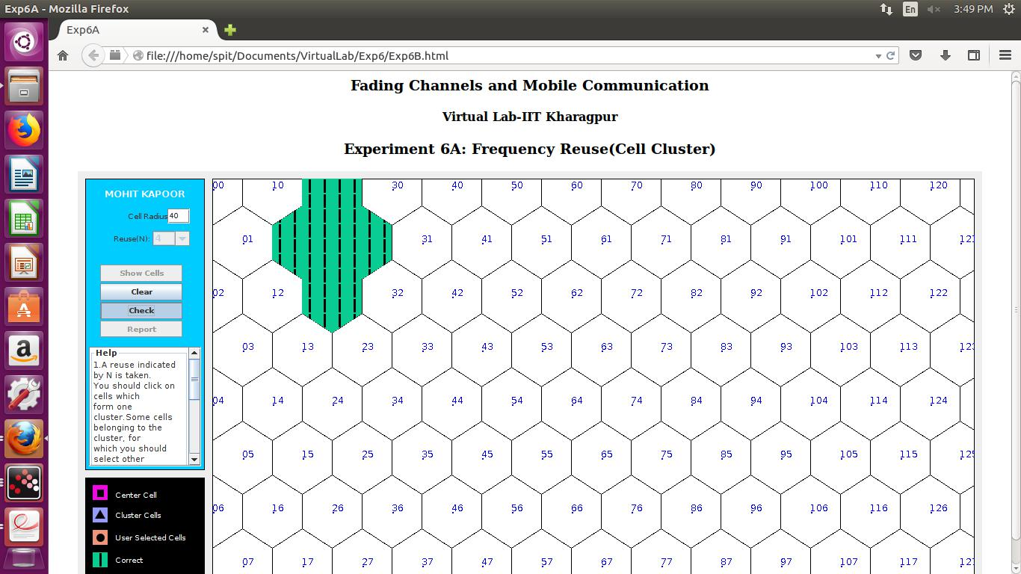

**Discussion:**

(Signature of MOHIT KAPOOR)

(Signature of Faculty)